**CICD EXPERIMENT – 1**

**Installation of Jenkins and execution of a basic job on Jenkins.**

Jenkins is a powerful tool that aids the process of Continuous Integration and Deployment. Note: For running Jenkins, JDK/JRE 8 to JDK/JRE 11 is required.

Installation of Jenkins requires following steps:

1. Go to the website <https://www.jenkins.io/download/> and download the Generic Java Package for Jenkins.

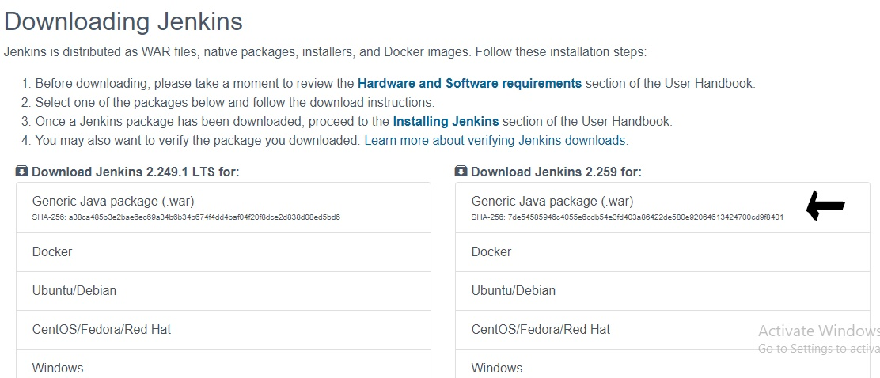

1. The above step will download a war file. Place the downloaded file at a desired location on the PC.

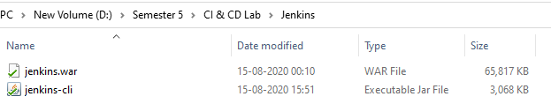

1. Open the command prompt and move to the directory where the file is stored and run the following command: java -jar jenkins.war

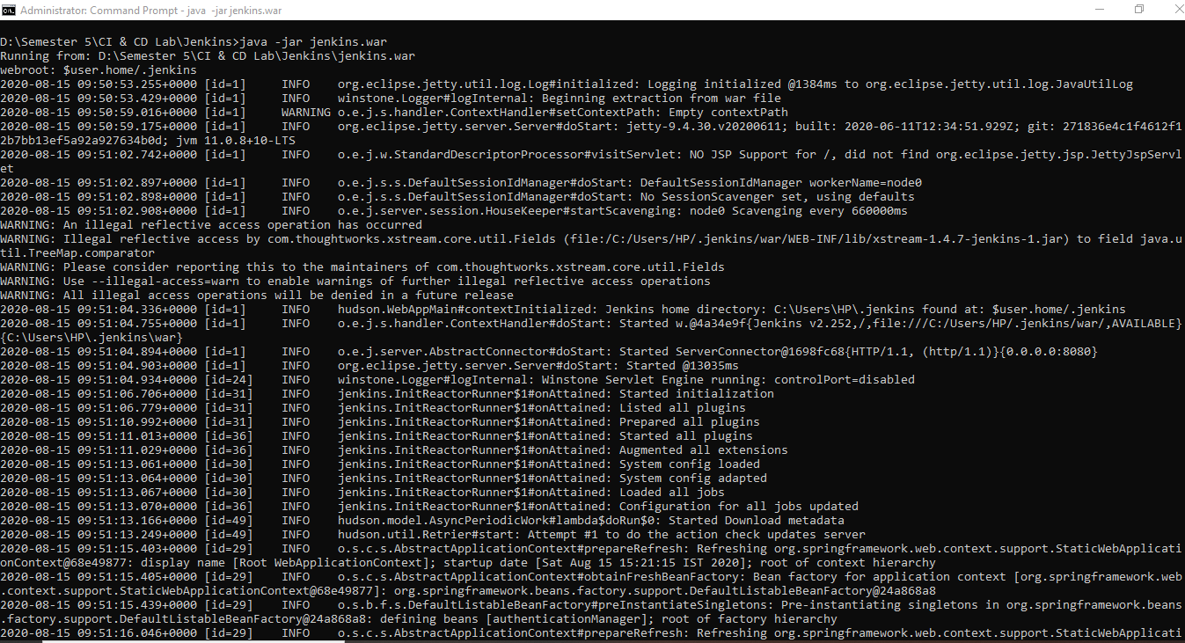

1. After the successful execution of the above command, you will get a message as below:

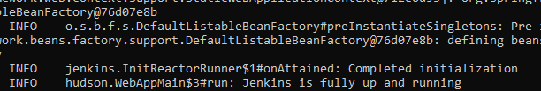

1. Now open localhost:8080 in your browser and you will get the following page:

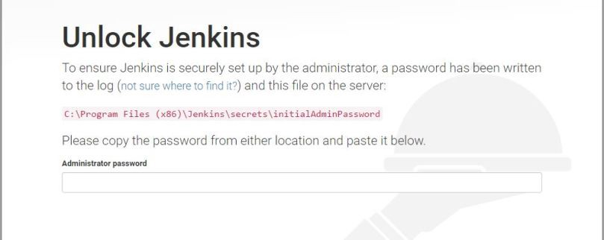

1. Go to the file path mentioned above and get the password (the path may be different in your case). Now you will be asked to download the suggested plugins.

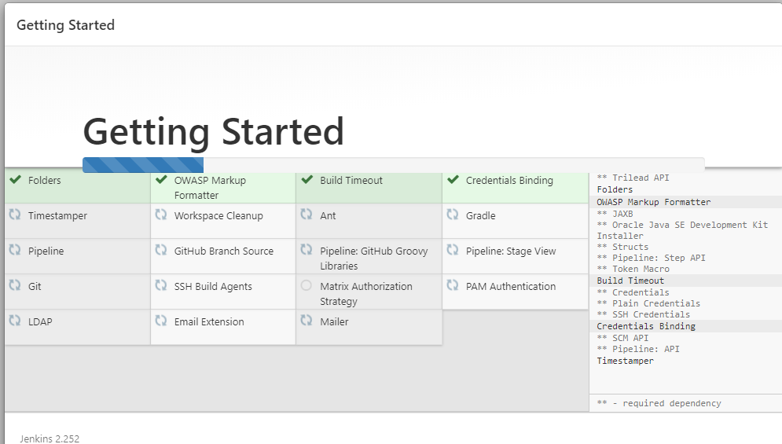

1. Now you are ready to get started with Jenkins. Provide your username and password and then sign in to the console.

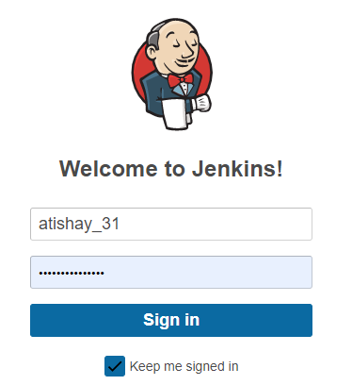

Simple job execution on Jenkins:

1. After logging in to Jenkins, select “New Item” to create a project.

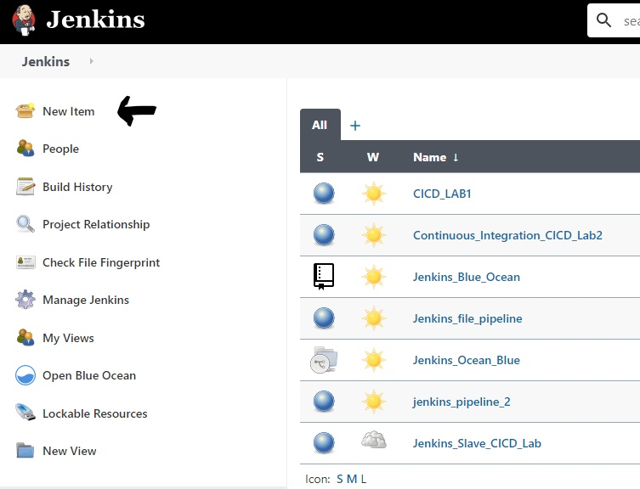

1. Write a name for the item and create a simple “Freestyle project”

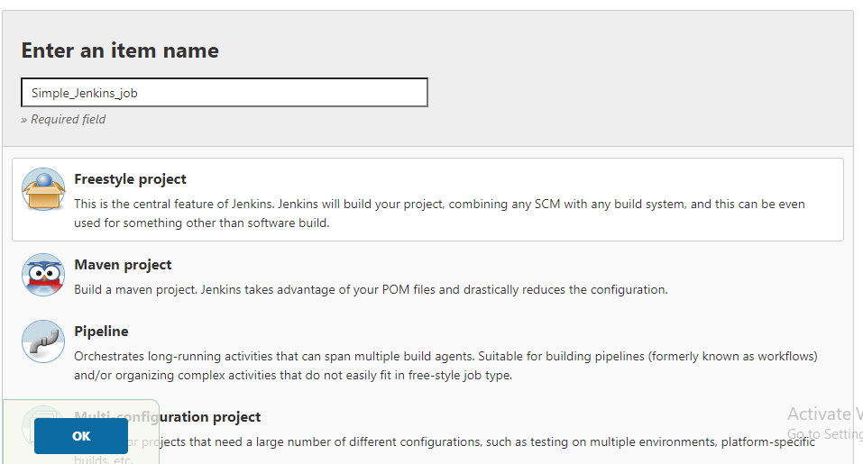

1. Write a description of the project(optional) and go to build section and select “Execute Windows Batch Command”. Write the command in the section and hit save button.

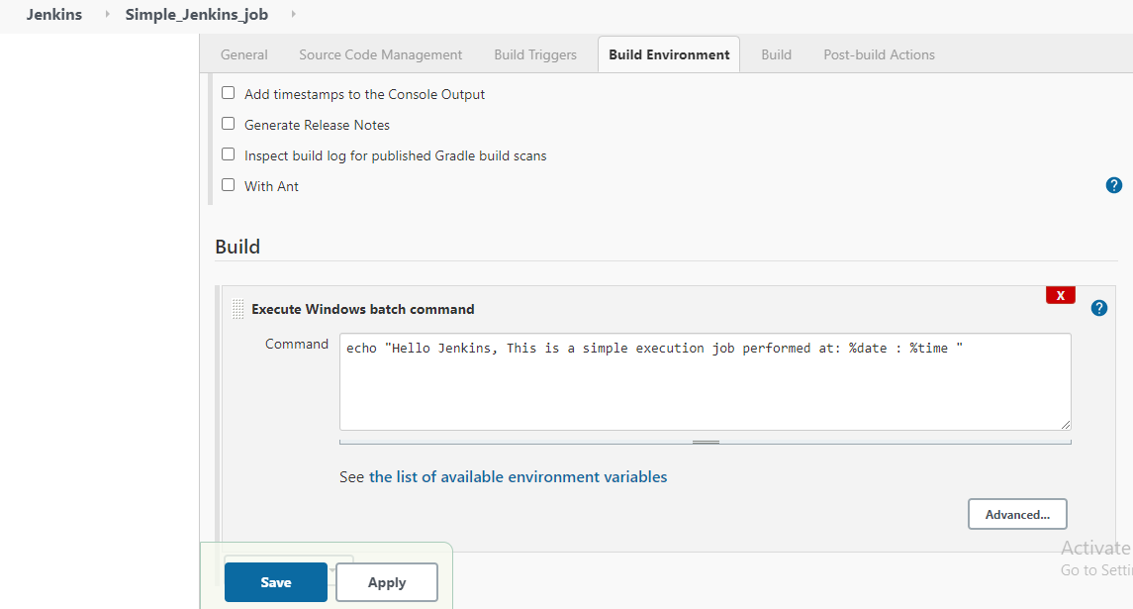

1. Now select “build now” option to build the project

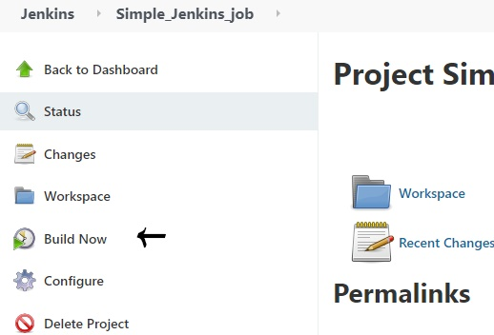

1. A build will be performed and a build history would be generated.

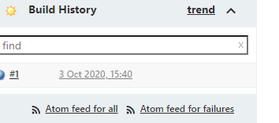

1. Now click on the build history and go to Console output to view the output.

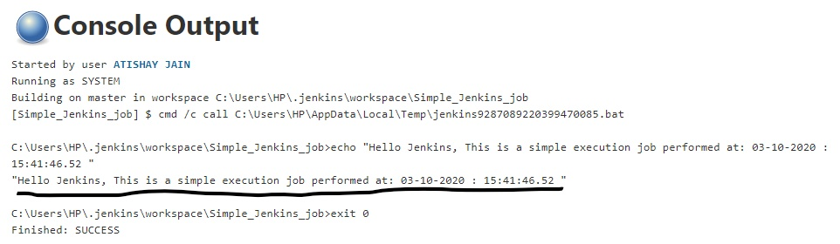

ATISHAY JAIN

500067694

R171218030

CSE, DEVOPS